**ME 361 LAB REPORT**

|  |  |  |
| --- | --- | --- |
| Experiment number | : | 4 |
|  |  |  |
| Sub-Group number | : | A4 |
|  |  |  |
| Name | : | AVINASH KUMAR |
|  |  |  |
| Roll number | : | 150169 |
|  |  |  |
| Date & Day experiment was conducted on | : | 7th Aug 2017 |
|  |  |  |
| Date of submission of report | : | 14th Aug 2017 |

**Experiment: Mechanistic identification of cutting force coefficients in milling.**

**Objective(s)**: To measure cutting forces and identify the cutting force coefficients.

**Answers to questions asked in the report:**

**1. Diameter = 12mm**

**Number of teeth = 4**

|  |  |  |  |  |  |  |  |  |  |
| --- | --- | --- | --- | --- | --- | --- | --- | --- | --- |
| Run | Axial DOC  (mm) | Radial engagement [% of D] | Feed/tooth  [mm/tooth] | Cutting speed  [mm/min] | Spindle speed [RPM] | Feed [mm/min] | Avg Fx (N) | Avg Fy (N) | Avg Fz (N) |
| 1 | 1 | 100 | 0.1 | 192.16 | 5100 | 2040 | -78.872 | 111.1496 | 77.05906 |
| 2 | 1 | 100 | 0.125 | 192.16 | 5100 | 2550 | -66.604 | -21.7388 | 110.5856 |
| 3 | 1 | 100 | 0.15 | 192.16 | 5100 | 3060 | -117.46 | 134.5888 | 86.00028 |
| 4 | 1 | 100 | 0.175 | 192.16 | 5100 | 3570 | -124.71 | 155.4845 | 82.65461 |

1. FEED = 2040 mm/min
2. FEED = 2550 mm/min

1. FEED = 3060 mm/min
2. FEED = 3570 mm/min

(2-3).

4. **From** the graph, and the equation, we infer

𝐹𝑞̅=𝐹𝑞𝑐̅̅̅̅ .𝑐+𝐹𝑞𝑒̅̅̅̅; 𝑞=𝑥,𝑦,𝑧

𝐹x𝑐 = -28.801 𝐹xe = 8.8726

𝐹𝑦𝑐= 33.441 𝐹𝑦e = -24.426

𝐹z𝑐= 17.425 𝐹ze = 18.985

Now we will use the following equations to find the cutting force coefficients :-

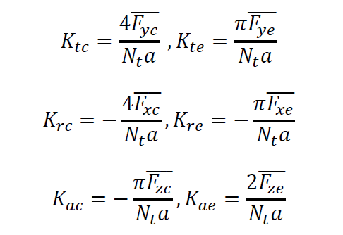

Here Nt = 4, a= 1mm

Which Gives

𝐾𝑡𝑐 = 33441 𝐾te = -19184.13

𝐾𝑟𝑐 = -28801 𝐾𝑟𝑒 = -6968.52

𝐾𝑎𝑐 = -13685.56 𝐾𝑎𝑒 = 9492.50